**Elastic search Create index:**

**Put:** [**http://localhost:9200/schools/**](http://localhost:9200/schools/)

**Response:**

**{**

**“acknowledged”: true,**

**“shards-acknowledged”: true,**

**“index”: “schools”**

**}**

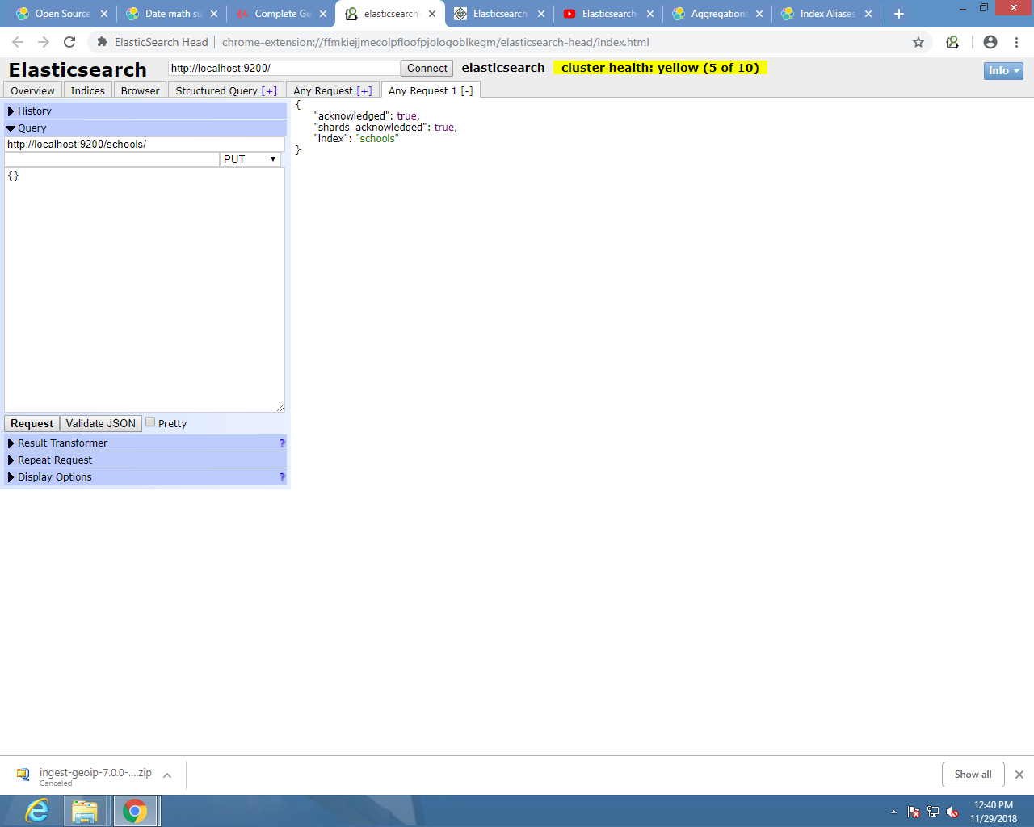

**Add Type to document:**

**POST:** [**http://localhost:9200/schools/school**](http://localhost:9200/schools/school)

**Request:**

**{**

**"name":"Central School", "description":"CBSE Affiliation", "street":"Nagan",**

**"city":"paprola", "state":"HP", "zip":"176115", "location":[31.8955385, 76.8380405],**

**"fees":2000, "tags":["Senior Secondary", "beautiful campus"], "rating":"3.5"**

**}**

**{**

**"name":"Crescent School", "description":"State Board Affiliation", "street":"Tonk Road",**

**"city":"Jaipur", "state":"RJ", "zip":"176114","location":[26.8535922, 75.7923988],**

**"fees":2500, "tags":["Well equipped labs"], "rating":"4.5"**

**}**

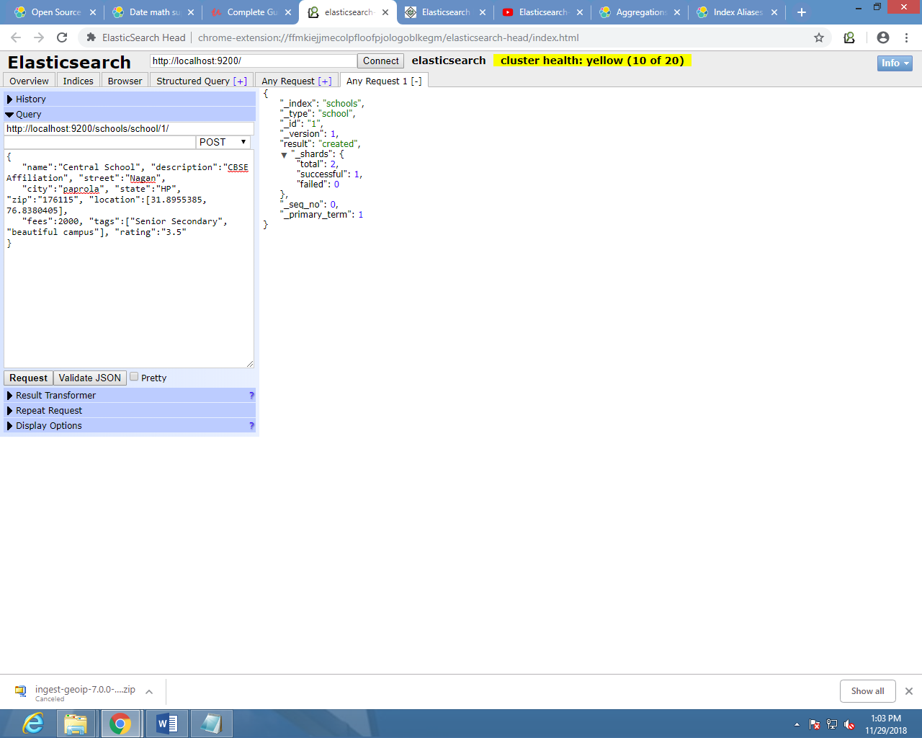

**Multiple indices Get Data**

**GET:** [**http://localhost:9200/test,schools/**](http://localhost:9200/test,schools/)

**Request:**

**{**

**"query":{**

**"query_string":{**

**"query":"any_string"**

**}**

**}}**

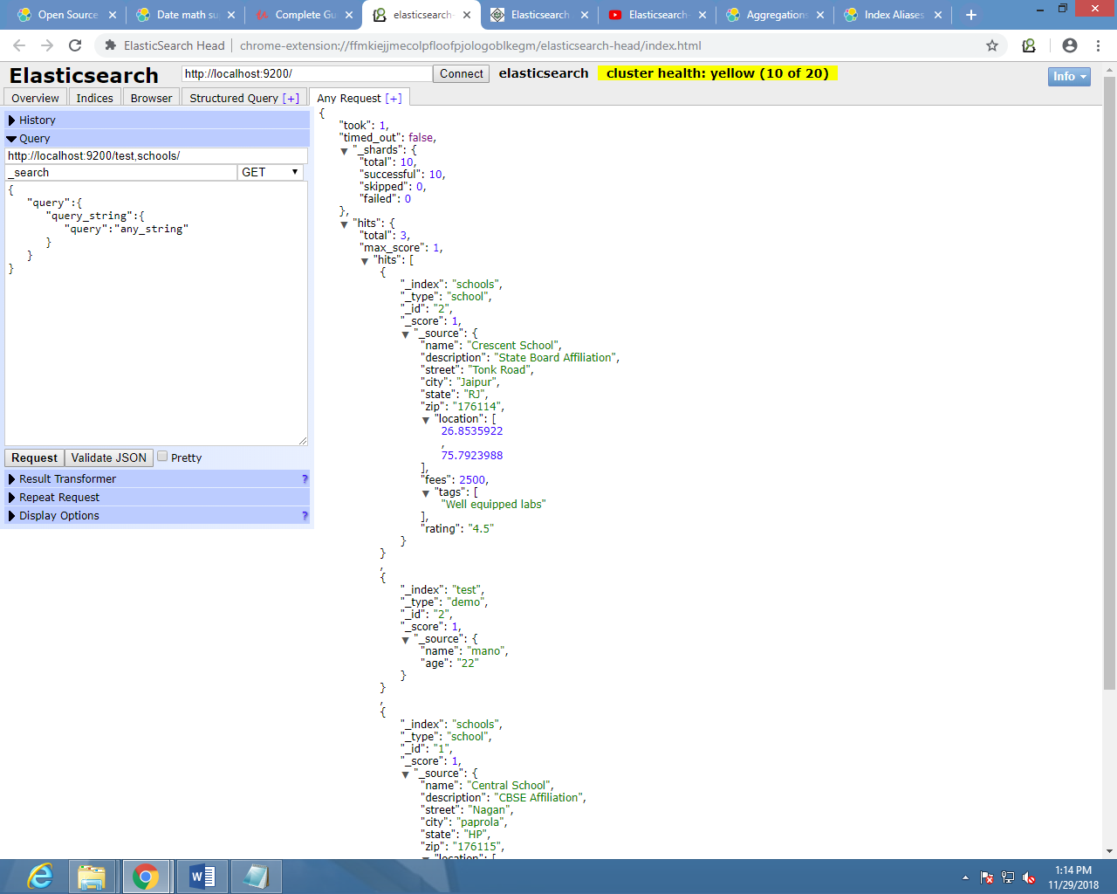

**Get specific value:**

**POST/GET** [**http://localhost:9200/test/_search?q=age:19**](http://localhost:9200/test/_search?q=age:19)

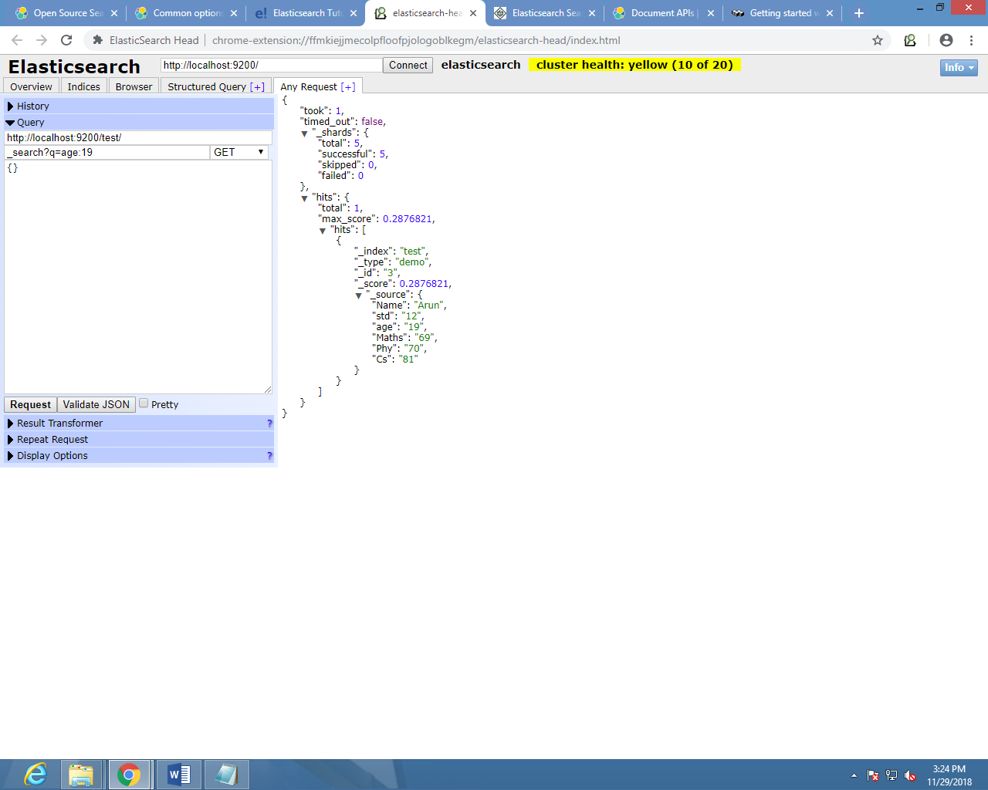

**Get specific String:**

**POST** [**http://localhost:9200/test/_search**](http://localhost:9200/test/_search) **only used post to specify the name else using get after execute to all data displays.**

**{**

**"query":{**

**"query_string":{**

**"query":"prasanth"**

**}**

**}**

**}**

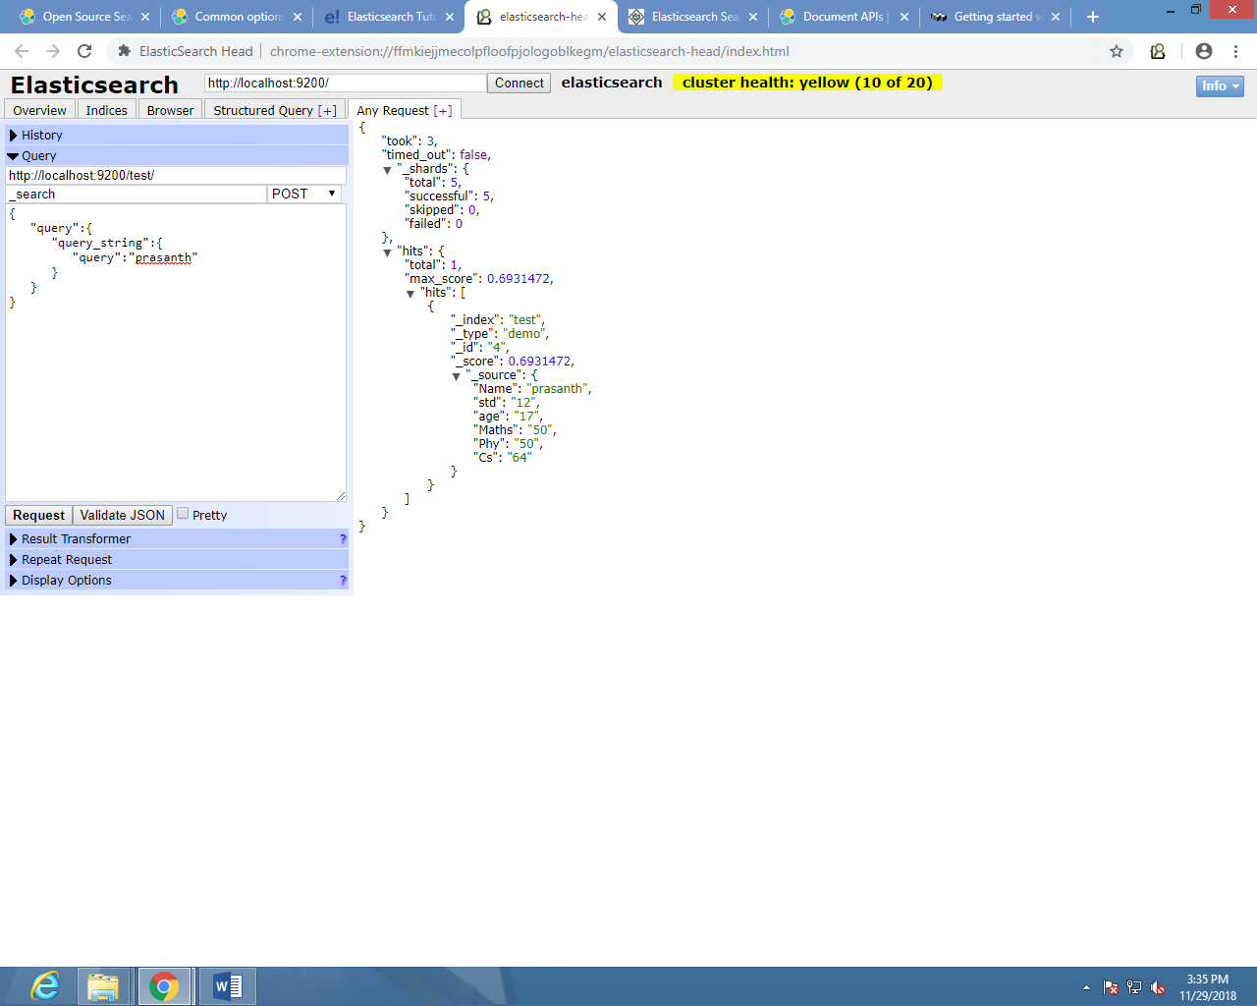

**Delete specific value:**

**Delete** [**https://localhost:9200/testdb/regi/**](https://localhost:9200/testdb/regi/)**9iA1bGkBCSVIlSoLd-3m**

